Jared Rivera 7 June 2017 804603106

CEE 103 HW#8

1)

**h=0.5**

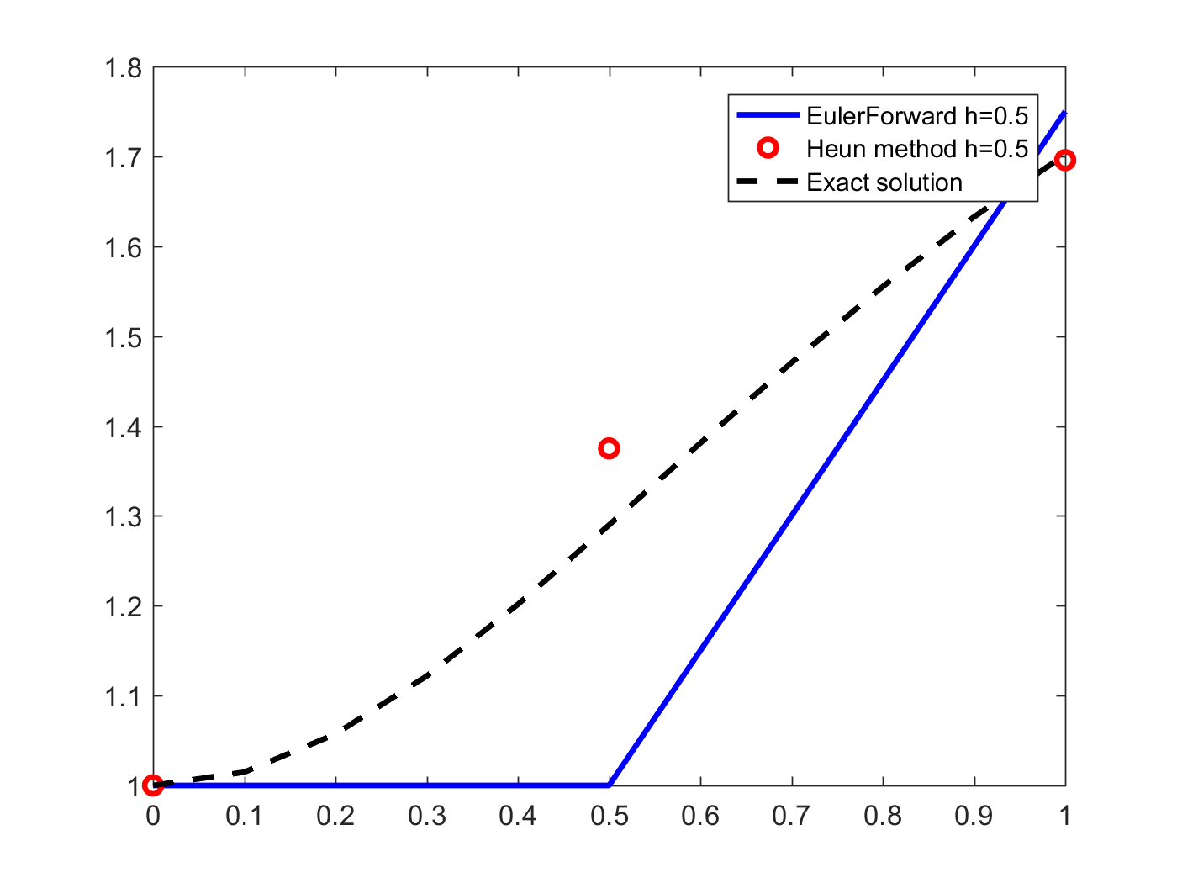Didn’t converge for the implicit methods,

x y_approximate y_exact Forward_Error

0.00000 1.0000 1.0000 0.0000e+00

0.50000 1.0000 1.6000 6.0000e-01

1.00000 1.7500 1.5000 -2.5000e-01

x y_approximate y_exact Heun_Error

0.00000 1.0000 1.0000 0.0000e+00

0.50000 1.3750 1.6000 2.2500e-01

1.00000 1.6958 1.5000 -1.9579e-01

**h=0.25**

x y_approximate y_exact Forward_Error

0.00000 1.0000 1.0000 0.0000e+00

0.25000 1.0000 1.4118 4.1176e-01

0.50000 1.1875 1.6000 4.1250e-01

0.75000 1.4601 1.6000 1.3988e-01

1.00000 1.7000 1.5000 -2.0000e-01

x y_approximate y_exact Heun_Error

0.00000 1.0000 1.0000 0.0000e+00

0.25000 1.0938 1.4118 3.1801e-01

0.50000 1.2949 1.6000 3.0515e-01

0.75000 1.5114 1.6000 8.8574e-02

1.00000 1.6923 1.5000 -1.9229e-01

x y_approximate y_exact Backward_PC_Error

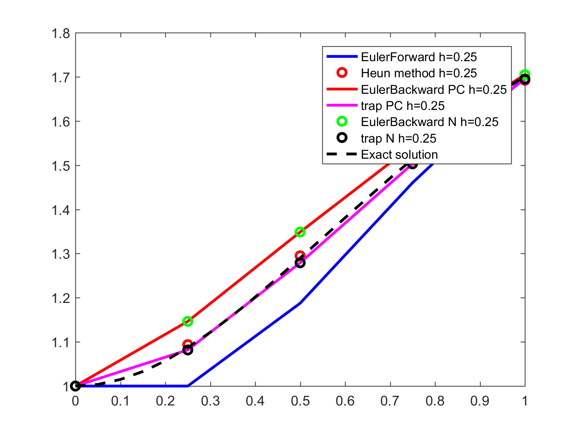0.00000 1.0000 1.0000 0.0000e+00

0.25000 1.1464 1.4118 2.6535e-01

0.50000 1.3486 1.6000 2.5140e-01

0.75000 1.5446 1.6000 5.5434e-02

1.00000 1.7049 1.5000 -2.0489e-01

x y_approximate y_exact Trap_PC_Error

0.00000 1.0000 1.0000 0.0000e+00

0.25000 1.0817 1.4118 3.3002e-01

0.50000 1.2790 1.6000 3.2098e-01

0.75000 1.5031 1.6000 9.6890e-02

1.00000 1.6948 1.5000 -1.9484e-01

x y_approximate y_exact Backward_N_Error

0.00000 1.0000 1.0000 0.0000e+00

0.25000 1.1464 1.4118 2.6535e-01

0.50000 1.3486 1.6000 2.5140e-01

0.75000 1.5446 1.6000 5.5434e-02

1.00000 1.7049 1.5000 -2.0489e-01

x y_approximate y_exact Trap_N_Error

0.00000 1.0000 1.0000 0.0000e+00

0.25000 1.0817 1.4118 3.3002e-01

0.50000 1.2790 1.6000 3.2098e-01

0.75000 1.5031 1.6000 9.6890e-02

1.00000 1.6948 1.5000 -1.9484e-01

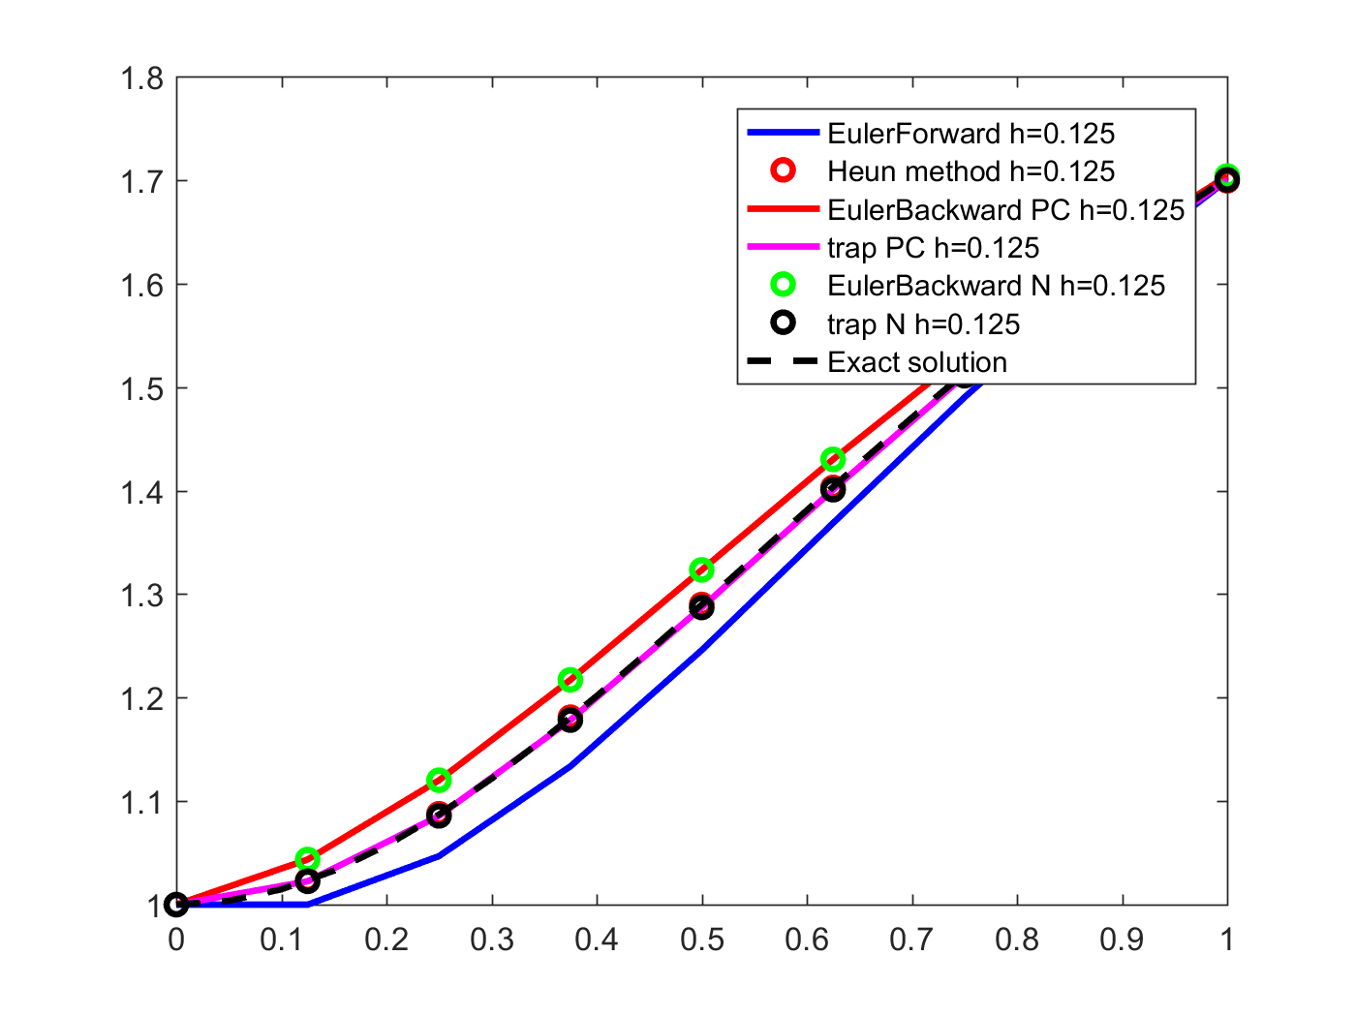**h=0.125**

x y_approximate y_exact Forward_Error

0.00000 1.0000 1.0000 0.0000e+00

0.12500 1.0000 1.2308 2.3077e-01

0.25000 1.0469 1.4118 3.6489e-01

0.37500 1.1336 1.5342 4.0068e-01

0.50000 1.2458 1.6000 3.5416e-01

0.62500 1.3686 1.6180 2.4934e-01

0.75000 1.4900 1.6000 1.0996e-01

0.87500 1.6020 1.5575 -4.4500e-02

1.00000 1.6999 1.5000 -1.9989e-01

x y_approximate y_exact Heun_Error

0.00000 1.0000 1.0000 0.0000e+00

0.12500 1.0234 1.2308 2.0733e-01

0.25000 1.0878 1.4118 3.2399e-01

0.37500 1.1811 1.5342 3.5319e-01

0.50000 1.2899 1.6000 3.1006e-01

0.62500 1.4031 1.6180 2.1490e-01

0.75000 1.5122 1.6000 8.7773e-02

0.87500 1.6120 1.5575 -5.4462e-02

1.00000 1.6993 1.5000 -1.9929e-01

x y_approximate y_exact Backward_PC_Error

0.00000 1.0000 1.0000 0.0000e+00

0.12500 1.0436 1.2308 1.8719e-01

0.25000 1.1202 1.4118 2.9160e-01

0.37500 1.2172 1.5342 3.1709e-01

0.50000 1.3234 1.6000 2.7664e-01

0.62500 1.4301 1.6180 1.8783e-01

0.75000 1.5314 1.6000 6.8561e-02

0.87500 1.6234 1.5575 -6.5859e-02

1.00000 1.7039 1.5000 -2.0385e-01

x y_approximate y_exact Trap_PC_Error

0.00000 1.0000 1.0000 0.0000e+00

0.12500 1.0226 1.2308 2.0820e-01

0.25000 1.0857 1.4118 3.2602e-01

0.37500 1.1783 1.5342 3.5596e-01

0.50000 1.2871 1.6000 3.1287e-01

0.62500 1.4008 1.6180 2.1713e-01

0.75000 1.5109 1.6000 8.9067e-02

0.87500 1.6118 1.5575 -5.4257e-02

1.00000 1.7001 1.5000 -2.0014e-01

x y_approximate y_exact Backward_N_Error

0.00000 1.0000 1.0000 0.0000e+00

0.12500 1.0436 1.2308 1.8719e-01

0.25000 1.1202 1.4118 2.9160e-01

0.37500 1.2172 1.5342 3.1709e-01

0.50000 1.3234 1.6000 2.7664e-01

0.62500 1.4301 1.6180 1.8783e-01

0.75000 1.5314 1.6000 6.8561e-02

0.87500 1.6234 1.5575 -6.5859e-02

1.00000 1.7039 1.5000 -2.0385e-01

x y_approximate y_exact Trap_N_Error

0.00000 1.0000 1.0000 0.0000e+00

0.12500 1.0226 1.2308 2.0820e-01

0.25000 1.0857 1.4118 3.2602e-01

0.37500 1.1783 1.5342 3.5596e-01

0.50000 1.2871 1.6000 3.1287e-01

0.62500 1.4008 1.6180 2.1713e-01

0.75000 1.5109 1.6000 8.9067e-02

0.87500 1.6118 1.5575 -5.4257e-02

1.00000 1.7001 1.5000 -2.0014e-01

**h=0.0625**

x y_approximate y_exact Forward_Error

0.00000 1.0000 1.0000 0.0000e+00

0.06250 1.0000 1.1206 1.2062e-01

0.12500 1.0117 1.2308 2.1905e-01

0.18750 1.0347 1.3283 2.9360e-01

0.25000 1.0679 1.4118 3.4388e-01

0.31250 1.1097 1.4804 3.7071e-01

0.37500 1.1584 1.5342 3.7580e-01

0.43750 1.2122 1.5738 3.6155e-01

0.50000 1.2693 1.6000 3.3070e-01

0.56250 1.3281 1.6142 2.8613e-01

0.62500 1.3873 1.6180 2.3067e-01

0.68750 1.4457 1.6127 1.6699e-01

0.75000 1.5025 1.6000 9.7493e-02

0.81250 1.5569 1.5812 2.4308e-02

0.87500 1.6083 1.5575 -5.0757e-02

0.93750 1.6563 1.5301 -1.2620e-01

1.00000 1.7008 1.5000 -2.0079e-01

x y_approximate y_exact Heun_Error

0.00000 1.0000 1.0000 0.0000e+00

0.06250 1.0059 1.1206 1.1476e-01

0.12500 1.0230 1.2308 2.0773e-01

0.18750 1.0506 1.3283 2.7769e-01

0.25000 1.0872 1.4118 3.2461e-01

0.31250 1.1310 1.4804 3.4939e-01

0.37500 1.1805 1.5342 3.5373e-01

0.43750 1.2339 1.5738 3.3985e-01

0.50000 1.2897 1.6000 3.1027e-01

0.56250 1.3466 1.6142 2.6765e-01

0.62500 1.4034 1.6180 2.1460e-01

0.68750 1.4591 1.6127 1.5359e-01

0.75000 1.5131 1.6000 8.6890e-02

0.81250 1.5647 1.5812 1.6485e-02

0.87500 1.6134 1.5575 -5.5910e-02

0.93750 1.6590 1.5301 -1.2887e-01

1.00000 1.7012 1.5000 -2.0122e-01

x y_approximate y_exact Backward_PC_Error

0.00000 1.0000 1.0000 0.0000e+00

0.06250 1.0115 1.1206 1.0913e-01

0.12500 1.0337 1.2308 1.9712e-01

0.18750 1.0652 1.3283 2.6312e-01

0.25000 1.1045 1.4118 3.0726e-01

0.31250 1.1500 1.4804 3.3045e-01

0.37500 1.2000 1.5342 3.3426e-01

0.43750 1.2530 1.5738 3.2076e-01

0.50000 1.3077 1.6000 2.9227e-01

0.56250 1.3630 1.6142 2.5126e-01

0.62500 1.4178 1.6180 2.0017e-01

0.68750 1.4714 1.6127 1.4134e-01

0.75000 1.5231 1.6000 7.6896e-02

0.81250 1.5724 1.5812 8.7440e-03

0.87500 1.6190 1.5575 -6.1485e-02

0.93750 1.6626 1.5301 -1.3242e-01

1.00000 1.7029 1.5000 -2.0293e-01

x y_approximate y_exact Trap_PC_Error

0.00000 1.0000 1.0000 0.0000e+00

0.06250 1.0058 1.1206 1.1482e-01

0.12500 1.0229 1.2308 2.0788e-01

0.18750 1.0503 1.3283 2.7798e-01

0.25000 1.0868 1.4118 3.2501e-01

0.31250 1.1305 1.4804 3.4990e-01

0.37500 1.1799 1.5342 3.5431e-01

0.43750 1.2333 1.5738 3.4045e-01

0.50000 1.2891 1.6000 3.1086e-01

0.56250 1.3461 1.6142 2.6819e-01

0.62500 1.4029 1.6180 2.1506e-01

0.68750 1.4588 1.6127 1.5396e-01

0.75000 1.5129 1.6000 8.7147e-02

0.81250 1.5646 1.5812 1.6622e-02

0.87500 1.6134 1.5575 -5.5896e-02

0.93750 1.6591 1.5301 -1.2897e-01

1.00000 1.7014 1.5000 -2.0144e-01

x y_approximate y_exact Backward_N_Error

0.00000 1.0000 1.0000 0.0000e+00

0.06250 1.0115 1.1206 1.0913e-01

0.12500 1.0337 1.2308 1.9712e-01

0.18750 1.0652 1.3283 2.6312e-01

0.25000 1.1045 1.4118 3.0726e-01

0.31250 1.1500 1.4804 3.3045e-01

0.37500 1.2000 1.5342 3.3426e-01

0.43750 1.2530 1.5738 3.2076e-01

0.50000 1.3077 1.6000 2.9227e-01

0.56250 1.3630 1.6142 2.5126e-01

0.62500 1.4178 1.6180 2.0017e-01

0.68750 1.4714 1.6127 1.4134e-01

0.75000 1.5231 1.6000 7.6896e-02

0.81250 1.5724 1.5812 8.7440e-03

0.87500 1.6190 1.5575 -6.1485e-02

0.93750 1.6626 1.5301 -1.3242e-01

1.00000 1.7029 1.5000 -2.0293e-01

x y_approximate y_exact Trap_N_Error

0.00000 1.0000 1.0000 0.0000e+00

0.06250 1.0058 1.1206 1.1482e-01

0.12500 1.0229 1.2308 2.0788e-01

0.18750 1.0503 1.3283 2.7798e-01

0.25000 1.0868 1.4118 3.2501e-01

0.31250 1.1305 1.4804 3.4990e-01

0.37500 1.1799 1.5342 3.5431e-01

0.43750 1.2333 1.5738 3.4045e-01

0.50000 1.2891 1.6000 3.1086e-01

0.56250 1.3461 1.6142 2.6819e-01

0.62500 1.4029 1.6180 2.1506e-01

0.68750 1.4588 1.6127 1.5396e-01

0.75000 1.5129 1.6000 8.7147e-02

0.81250 1.5646 1.5812 1.6622e-02

0.87500 1.6134 1.5575 -5.5896e-02

0.93750 1.6591 1.5301 -1.2897e-01

1.00000 1.7014 1.5000 -2.0144e-01

